Day 6

Overloading, C++ pointers, Dynamic Memory Allocation

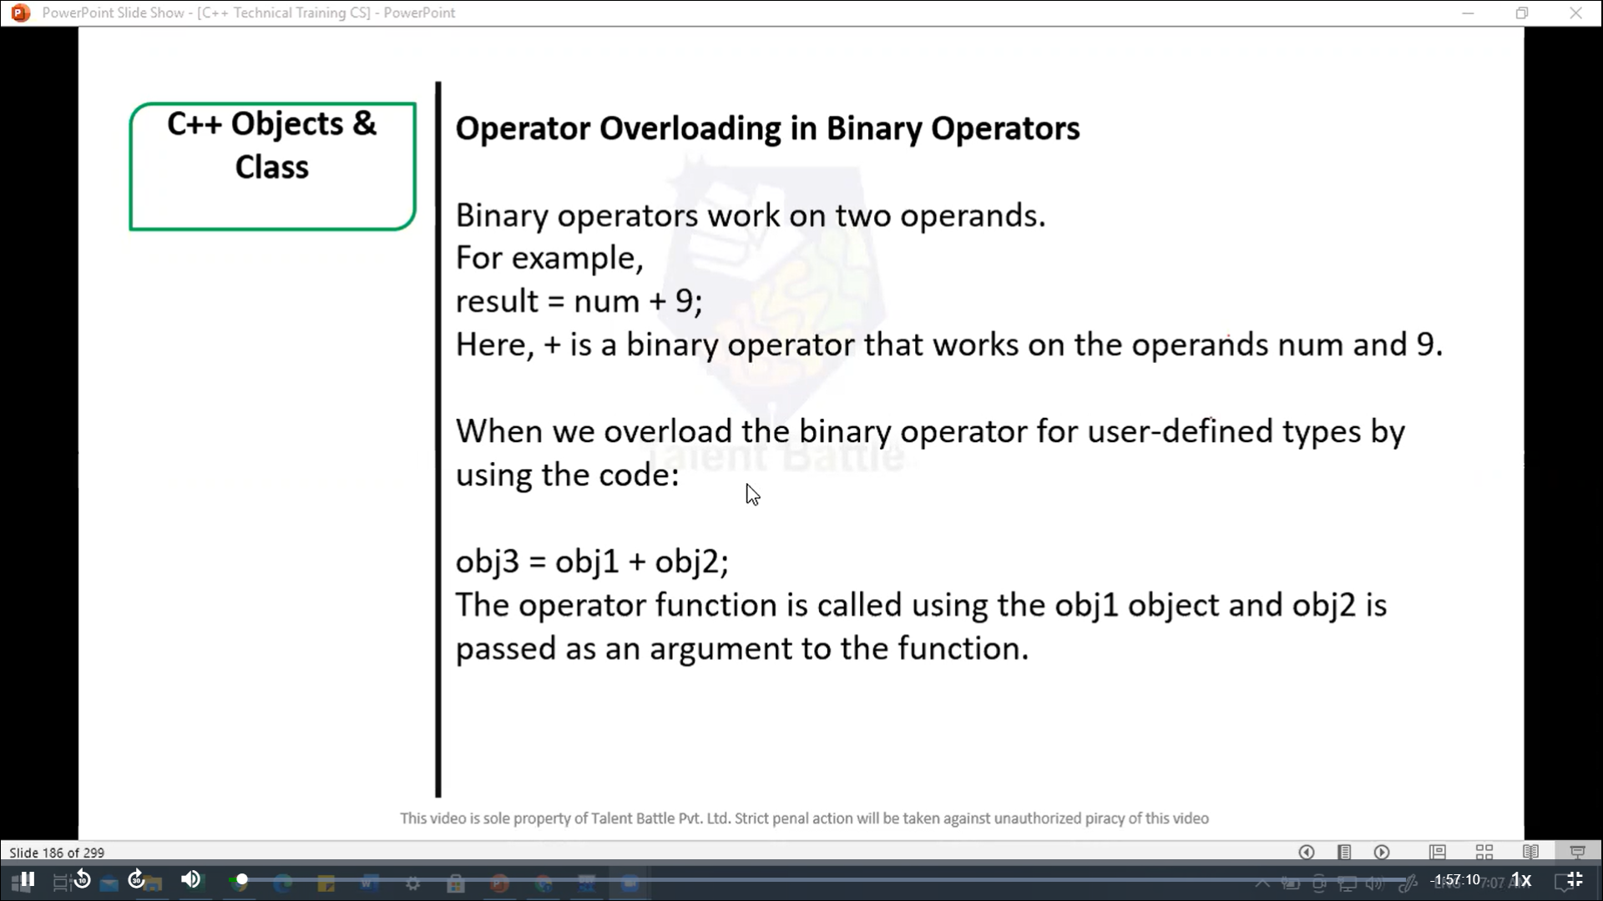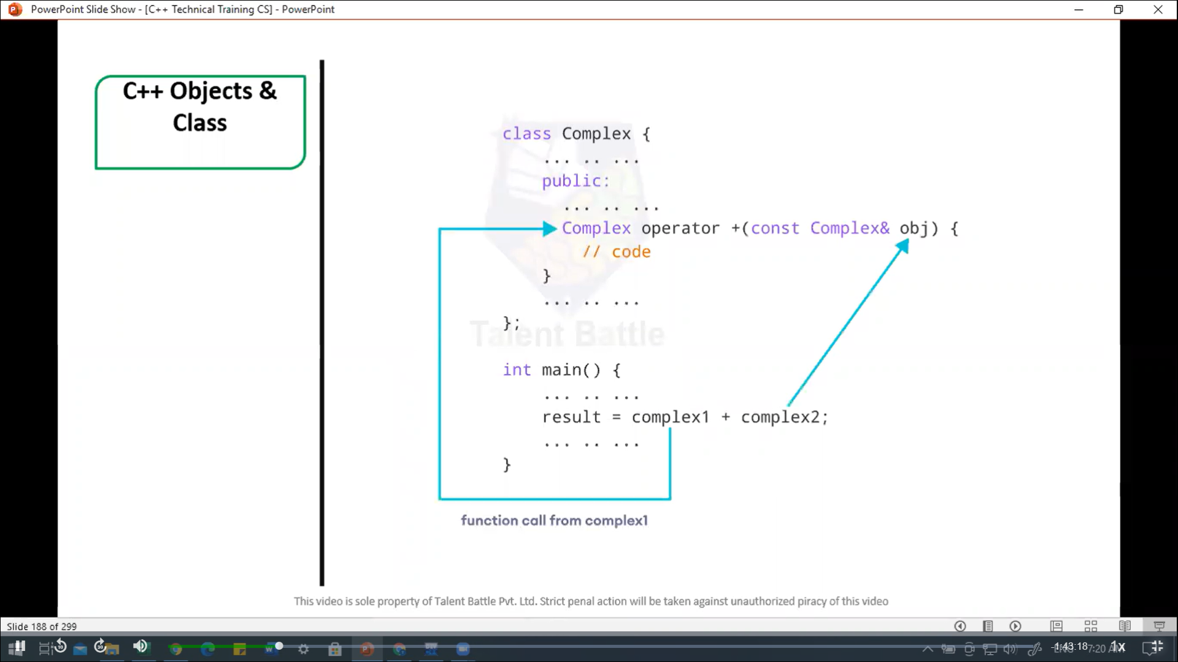

// C++ program to overload the binary operator +

//This program adds two complex numbers

#include<iostream>

using namespace ***std***;

*class* Complex{

  private***:***

    float real;

    float imag;

  public***:***

    // Constructor to initialize real and image to 0

*Complex*() ***:*** real(0)***,*** imag(0){}

    void *input*(){

      cout *<<* "Enter real and imaginary parts respectively: ";

      cin *>>* real;

      cin *>>* imag;

    }

    // Overload the + operator

    Complex *operator +*(const Complex& ***obj***){

      Complex temp;

      temp***.***real = real + ***obj.***real;

      temp***.***imag = imag + ***obj.***imag;

      return temp;

    }

    void *output*(){

      if(imag < 0){

        cout *<<* "Output Complex number: " *<<* real *<<* imag *<<* "i";

      }

      else{

        cout *<<* "Output Complex number: " *<<* real *<<* " + " *<<* imag *<<* "i";

      }

    }

};

int *main*(){

  Complex complex1***,*** complex2***,*** result;

  cout *<<* "Enter first complex number:**\n**";

  complex1***.****input*();

  cout *<<* "Enter second complex number:**\n**";

  complex2***.****input*();

  // complex1 call the operator function

  // complex2 is passed as an argument to the function

  result *=* complex1 *+* complex2;

  result***.****output*();

  return 0;

}

/*

Enter first complex number:

Enter real and imaginary parts respectively: 4

3

Enter second complex number:

Enter real and imaginary parts respectively: 3

5

Output Complex number: 7 + 8i

--------------------------------

Process exited after 4.714 seconds with return value 0

Press any key to continue . . .

*/

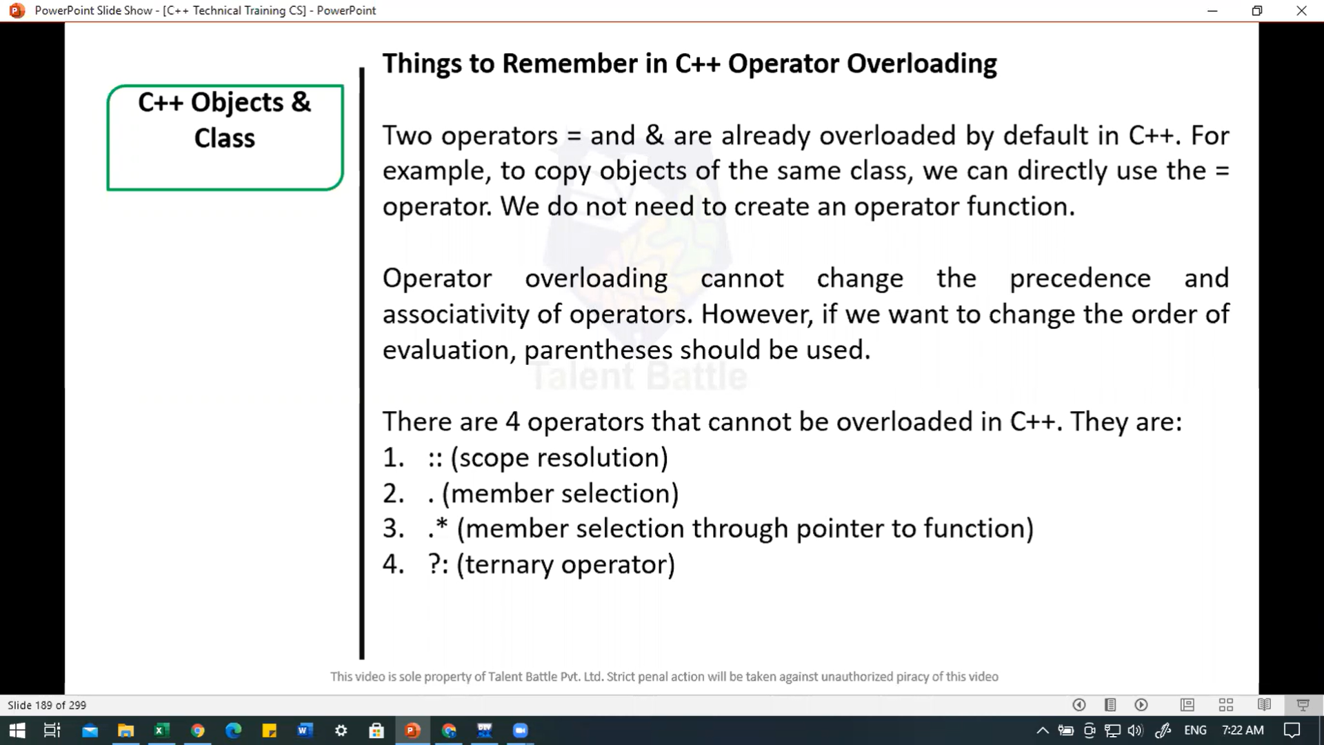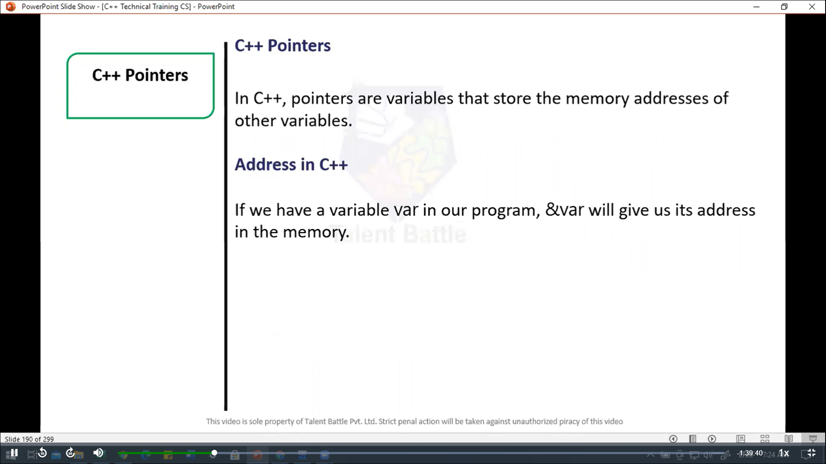

//===============================================

// C++ pointer

#include <iostream>

using namespace ***std***;

int *main*(){

  // declare variiables

  int var1 = 3;

  int var2 = 24;

  int var3 = 17;

  // print address of var1

  cout *<<* "Address of var1: " *<<* ***&***var1 *<<* *endl*;

  // print address of var2

  cout *<<* "Address of var2: " *<<* ***&***var2 *<<* *endl*;

  // print address of var3

  cout *<<* "Address of var3: " *<<* ***&***var3 *<<* *endl*;

  return 0;

}

/*

Address of var1: 0x6ffe1c

Address of var2: 0x6ffe18

Address of var3: 0x6ffe14

--------------------------------

Process exited after 0.06599 seconds with return value 0

*/

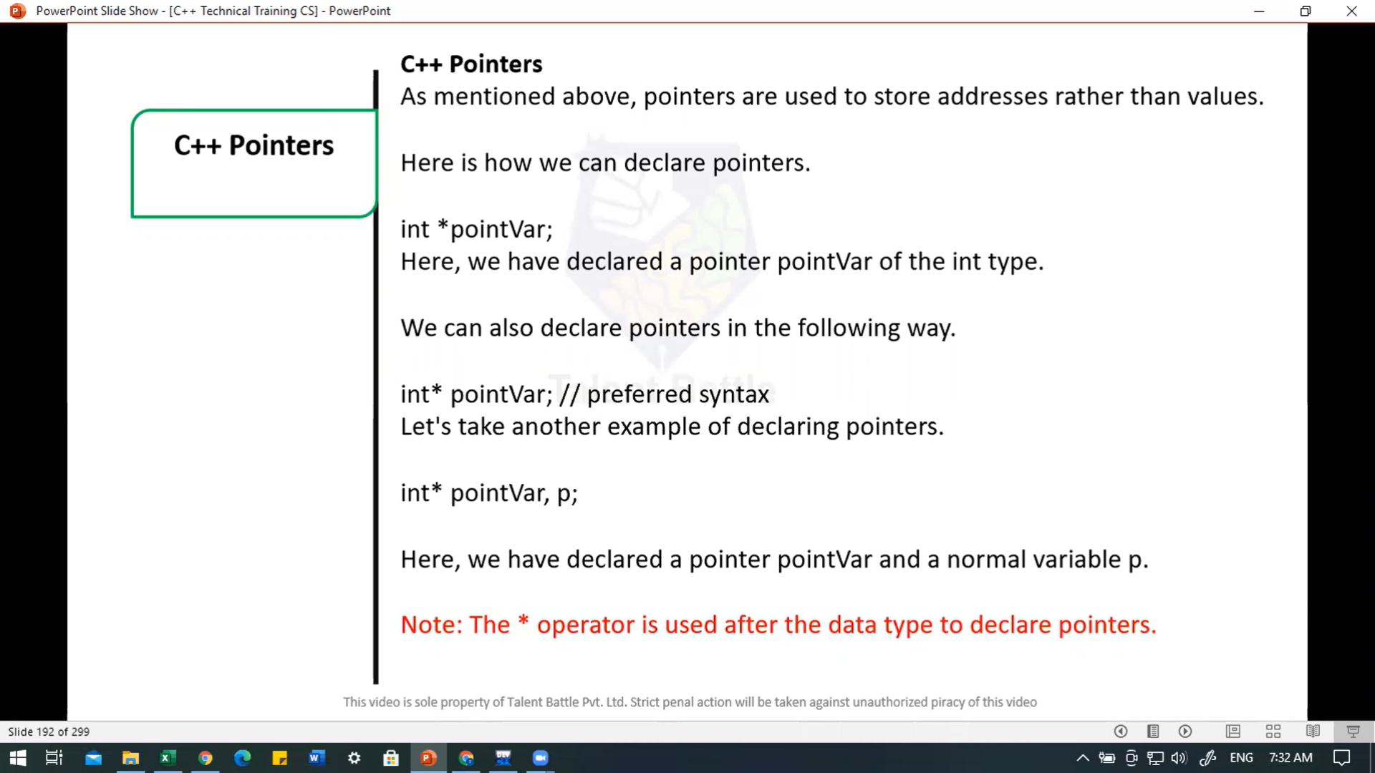

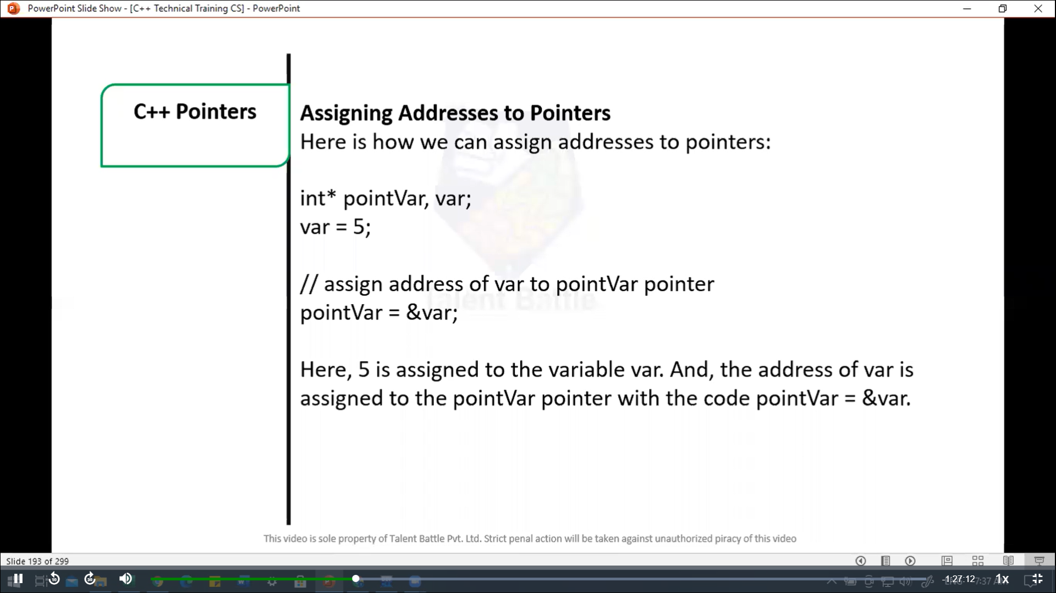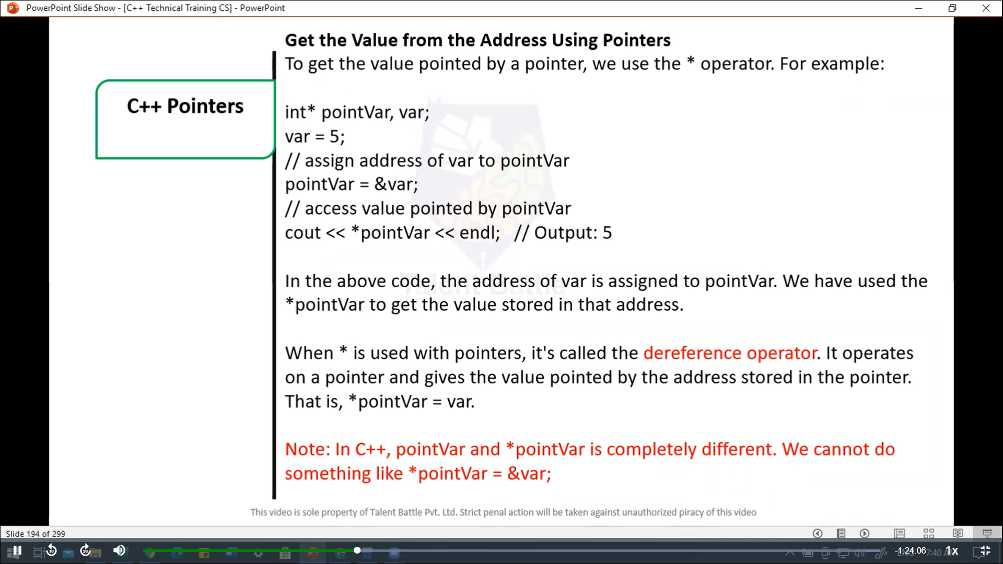

//========================================

// c++ pointer

#include<iostream>

using namespace ***std***;

int *main*(){

  int var = 5;

  // declare pointer variable

  int* pointVar;

  // store address of var

  pointVar = ***&***var;

  // print value of var

  cout *<<* "var = " *<<* var *<<* *endl*;

  // print address of var

  cout *<<* "Address of var (&var) = " *<<* ***&***var *<<* *endl* *<<* *endl*;

  // print pointer pointVar

  cout *<<* "pointVar = " *<<* pointVar *<<* *endl*;

  // print the content of the address pointVar points to

  cout *<<* "Content of the address pointed to by pointVar (*pointVar) = "*<<* *pointVar *<<* *endl*;

  return 0;

}

/*

var = 5

Address of var (&var) = 0x6ffe04

pointVar = 0x6ffe04

Content of the address pointed to by pointVar (*pointVar) = 5

--------------------------------

Process exited after 0.07561 seconds with return value 0

*/

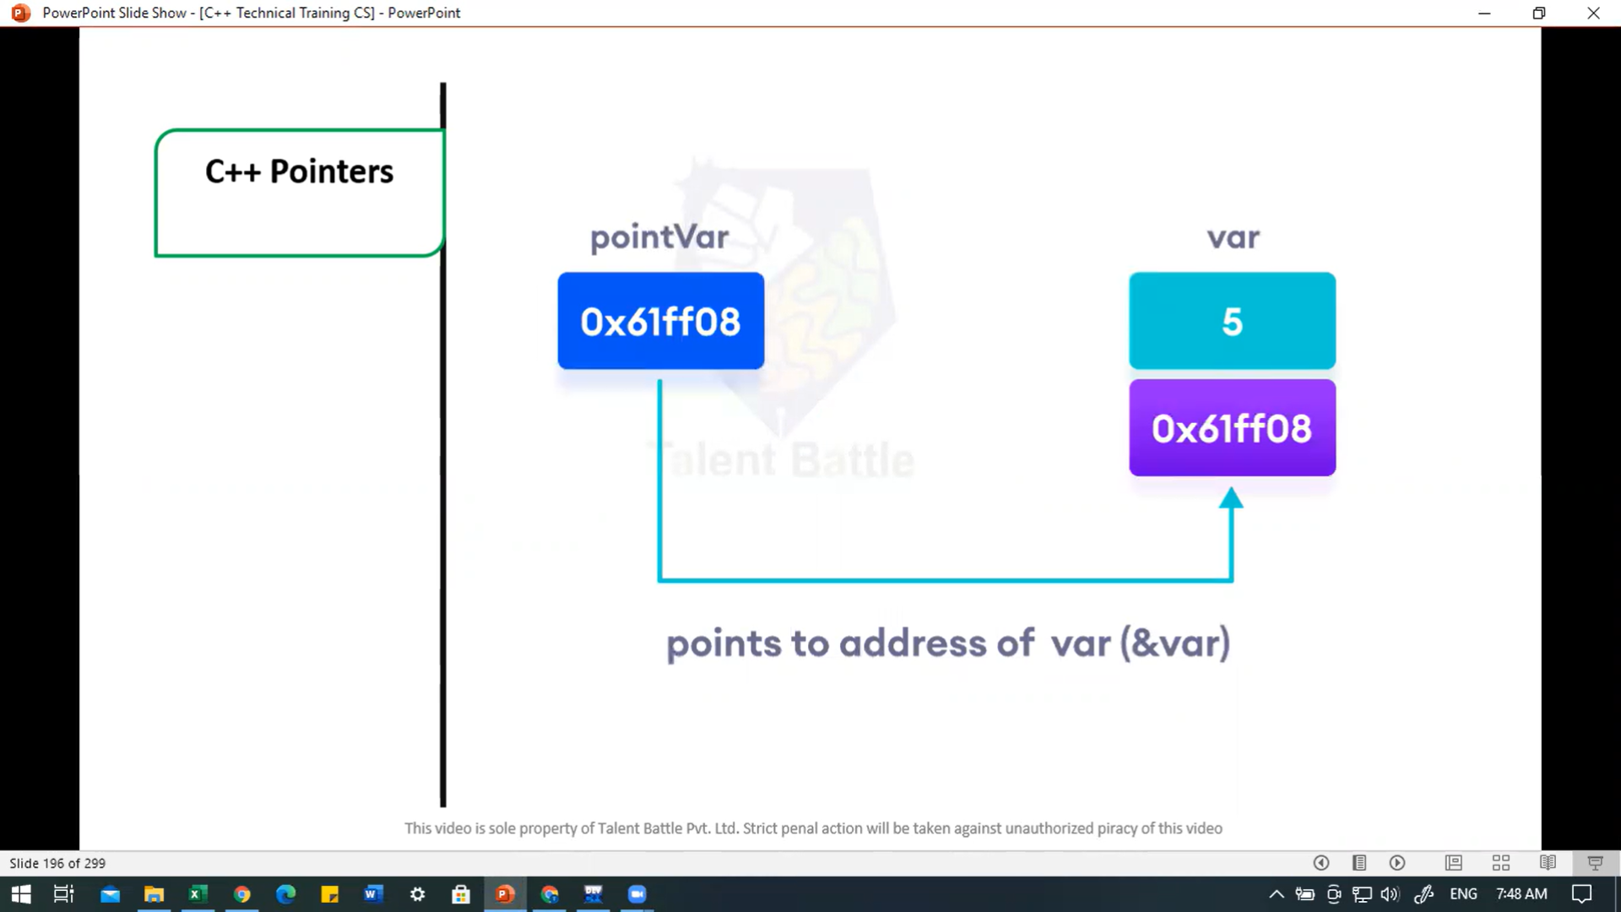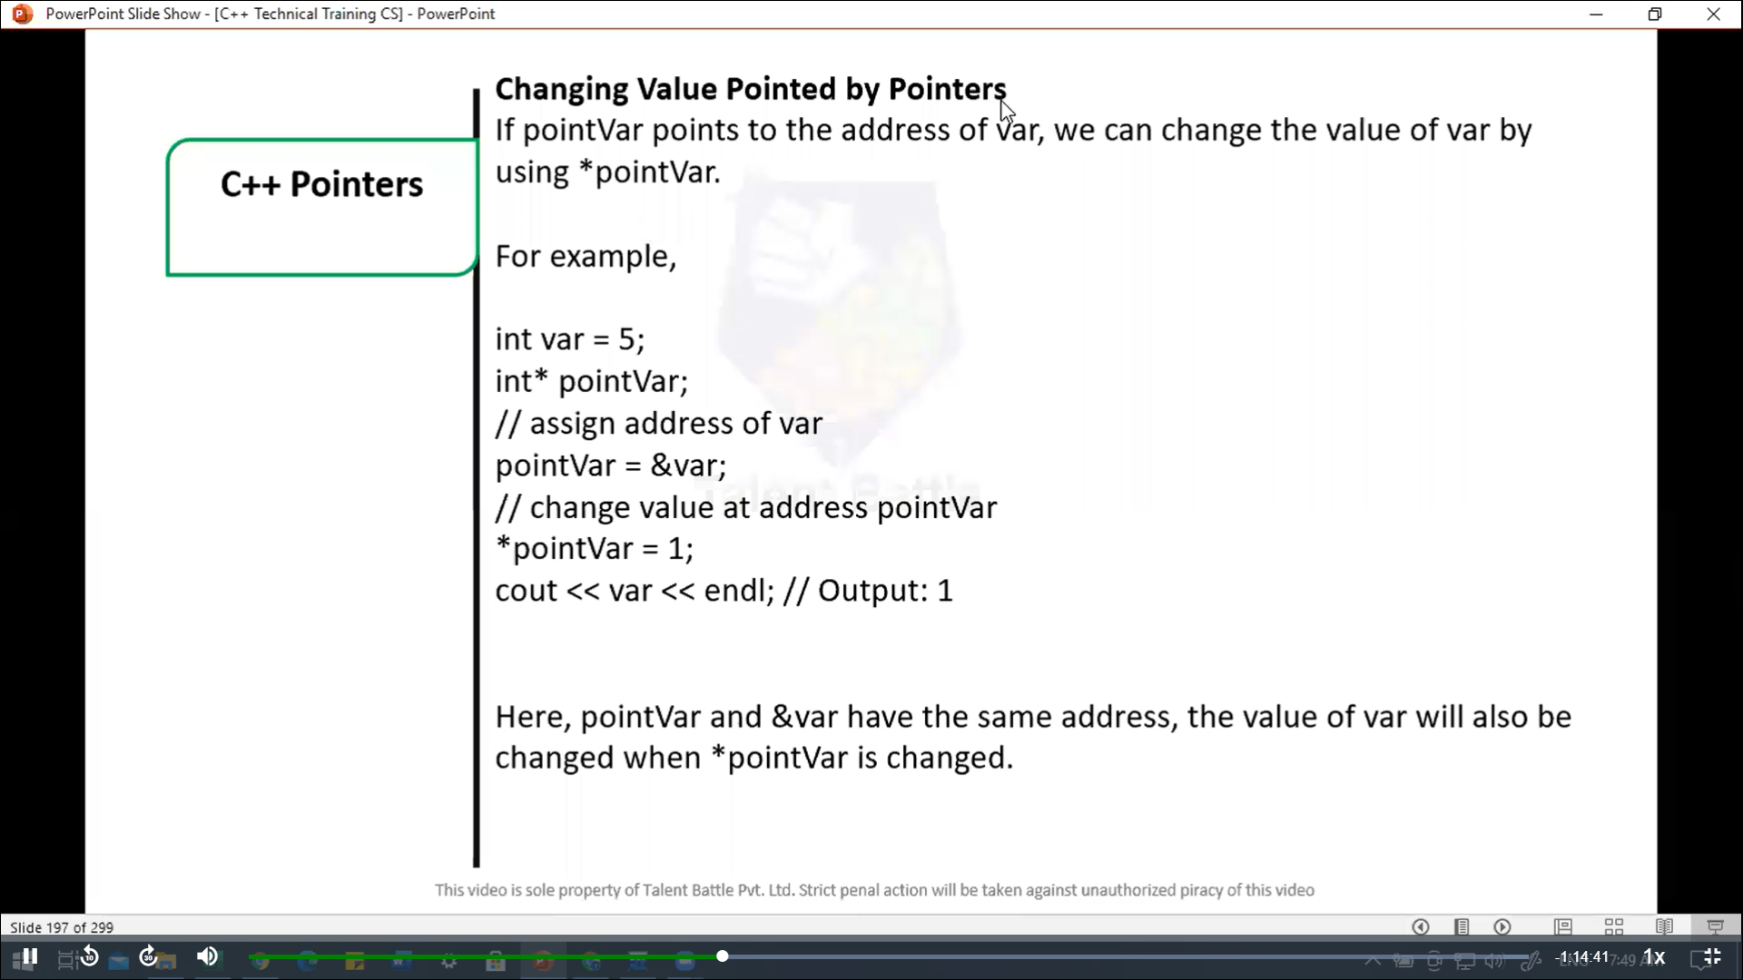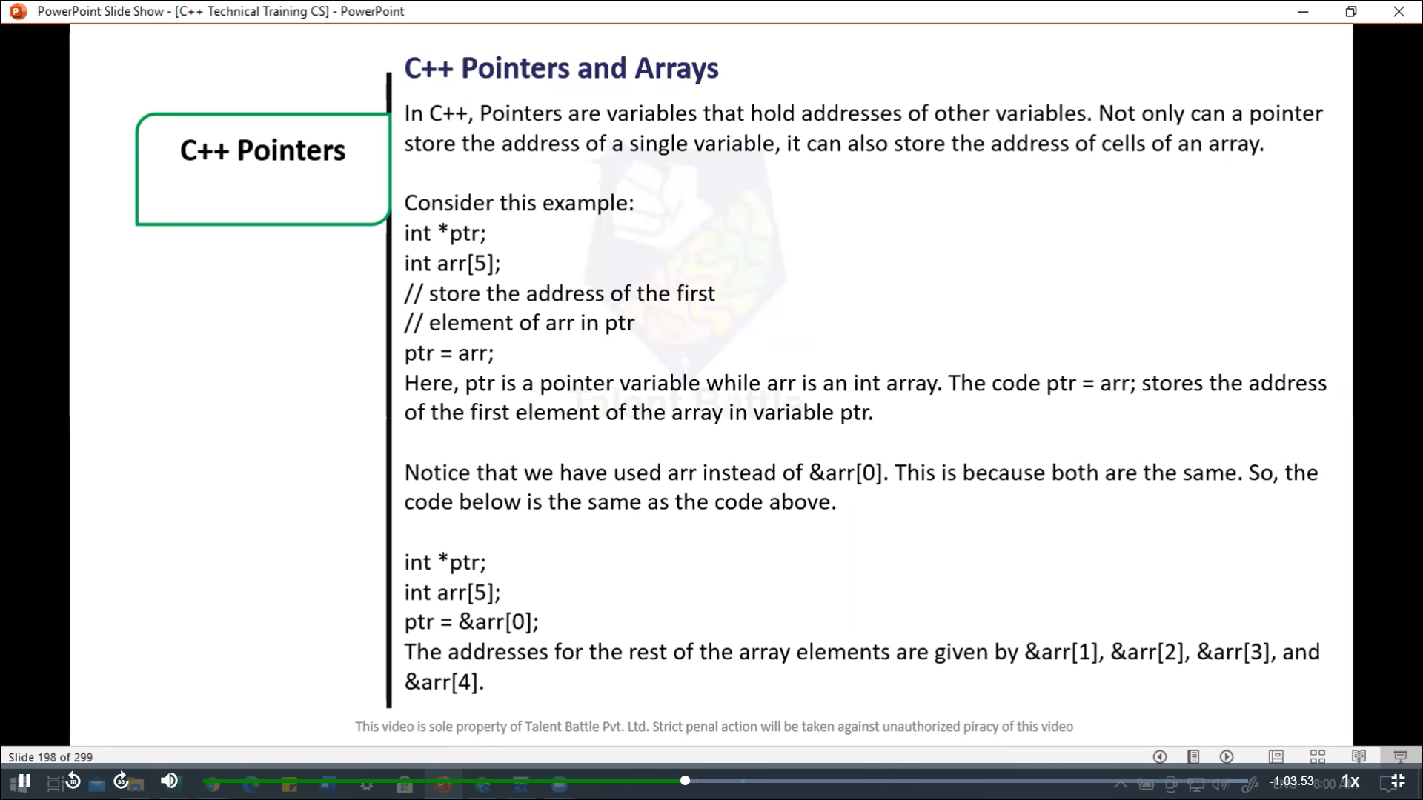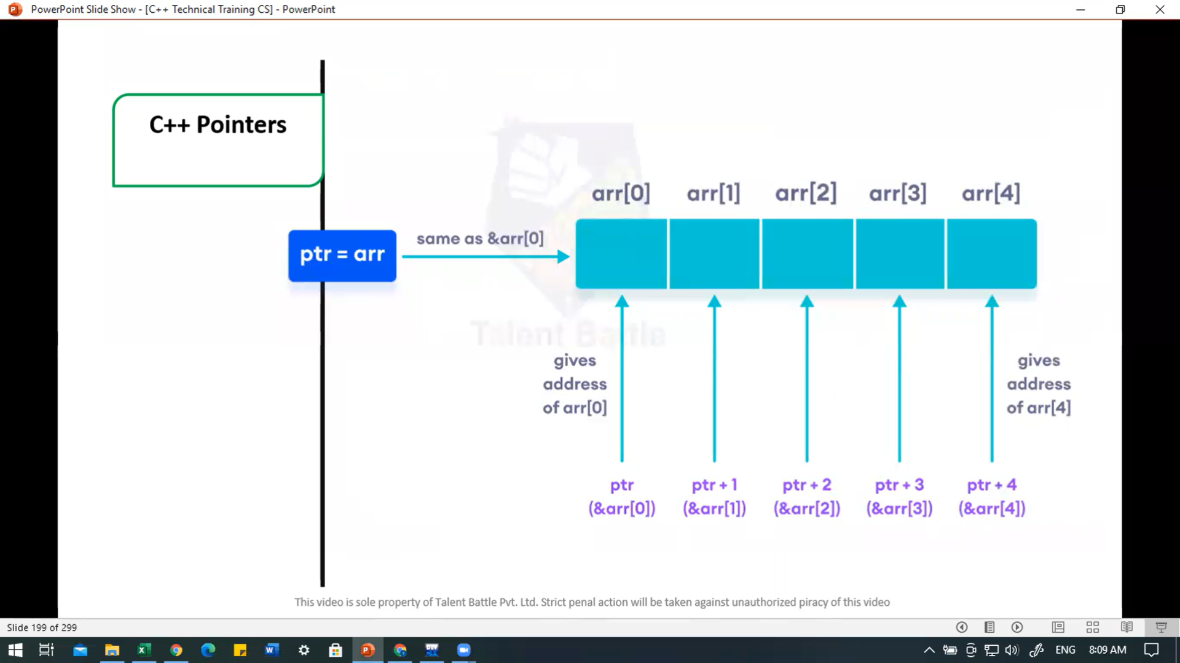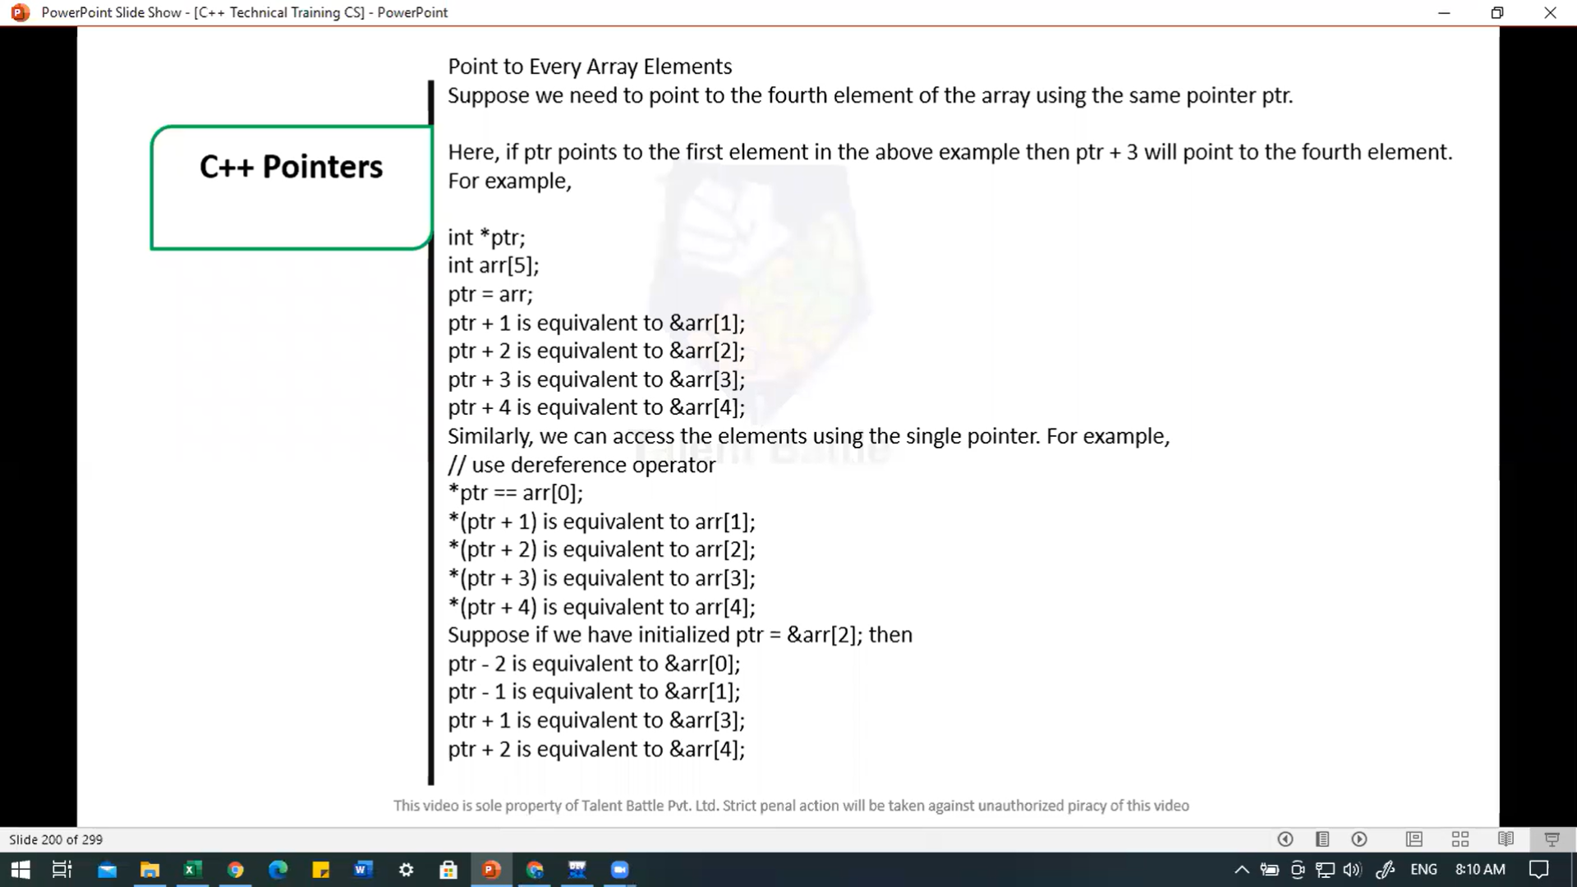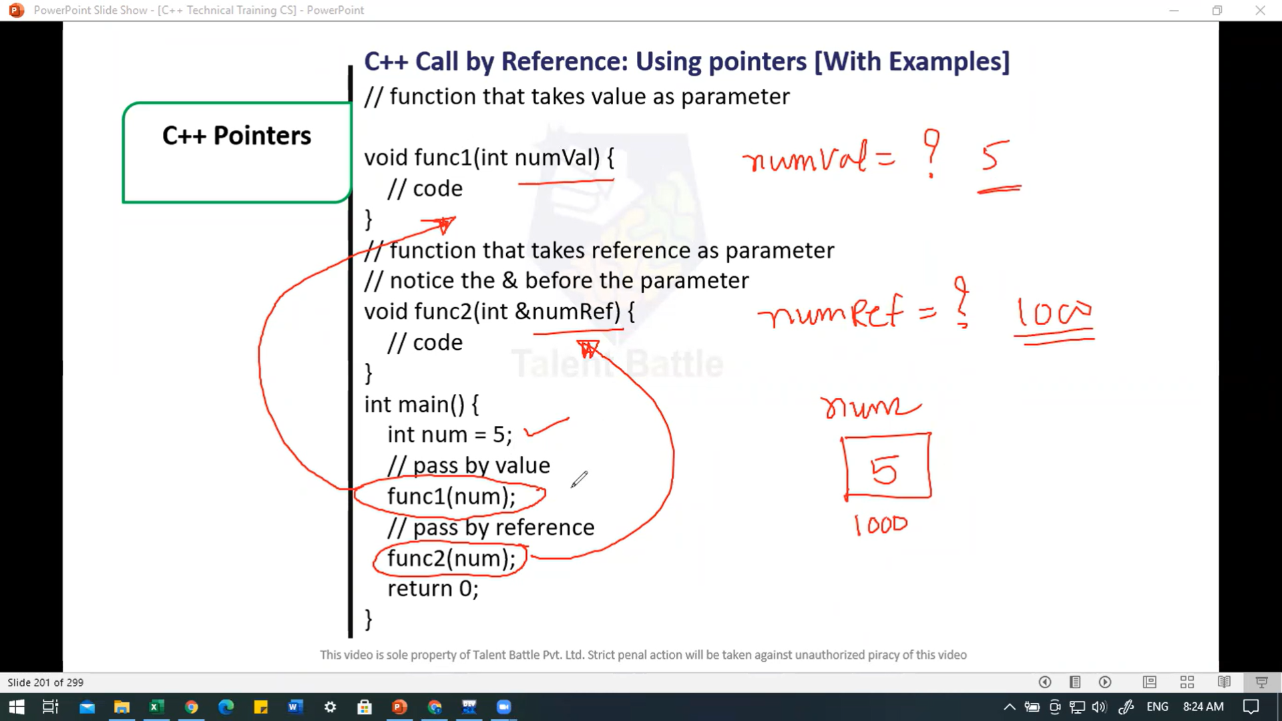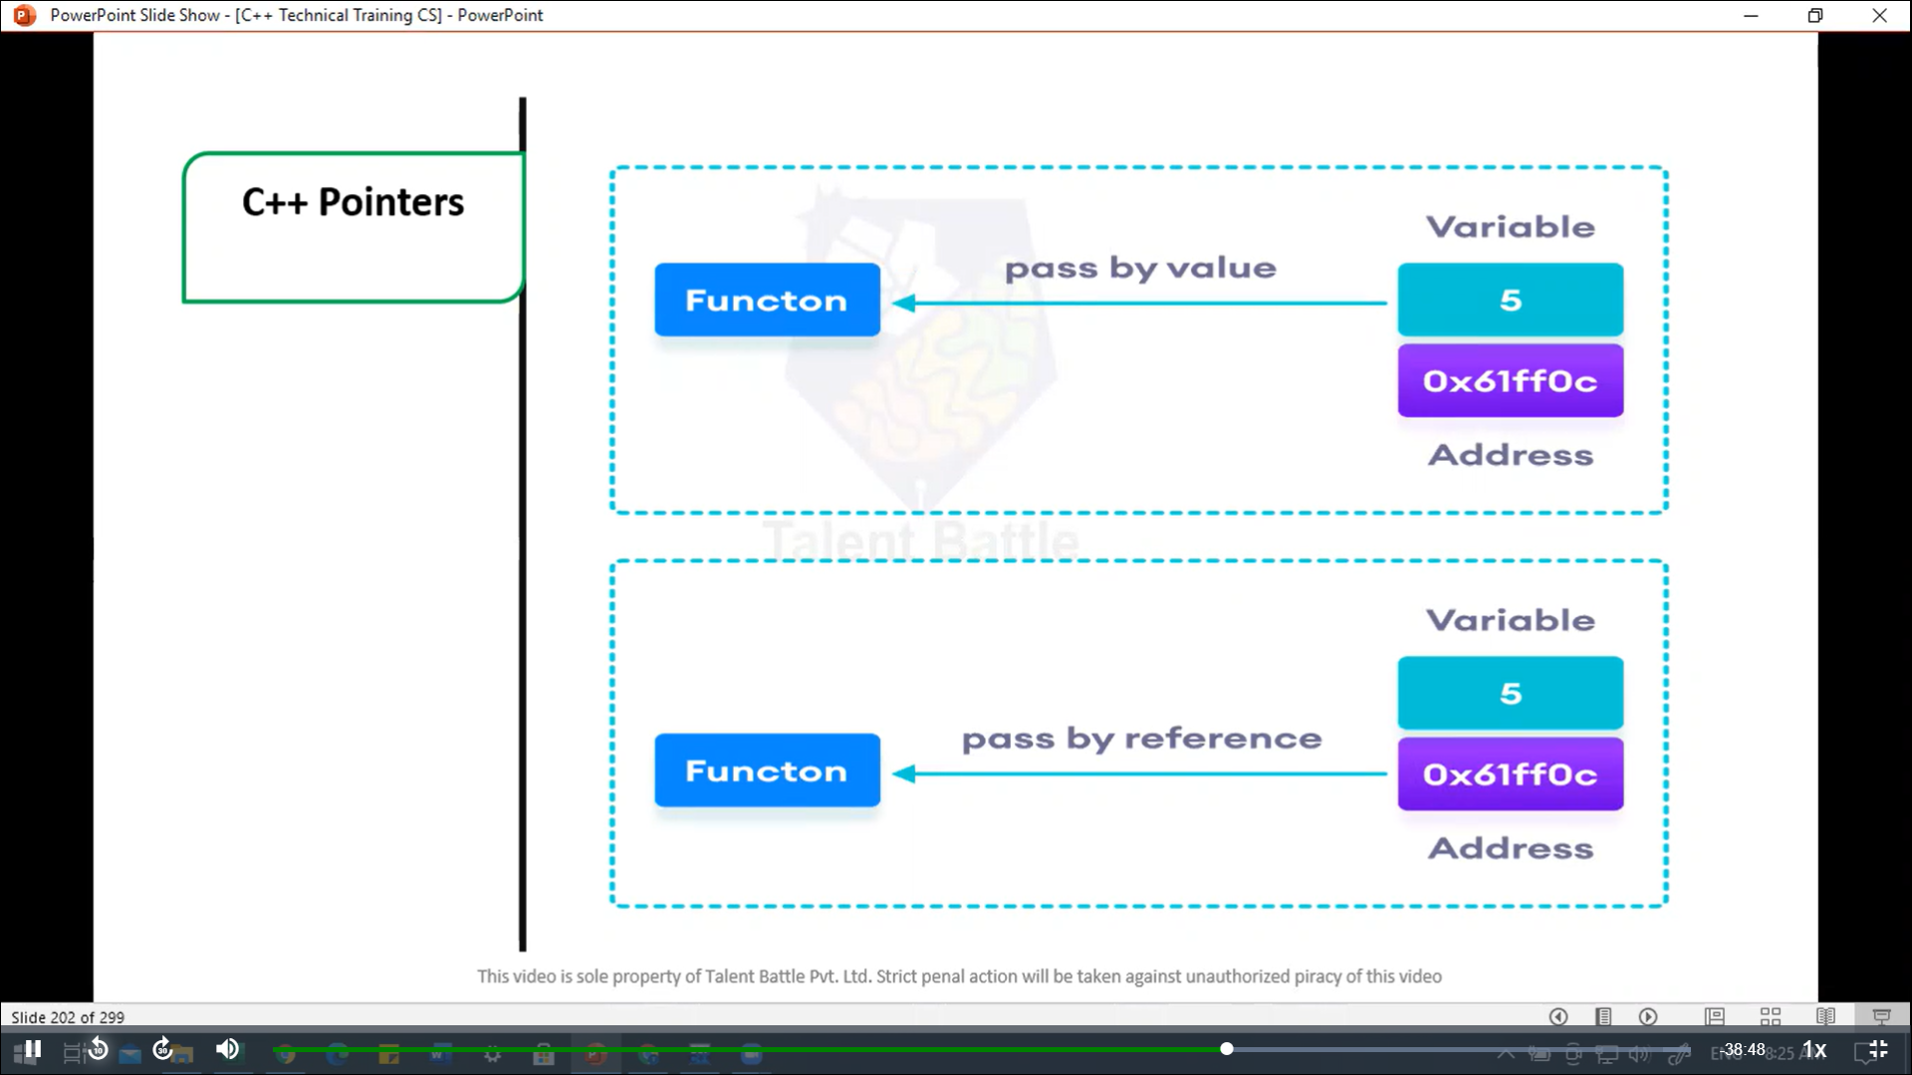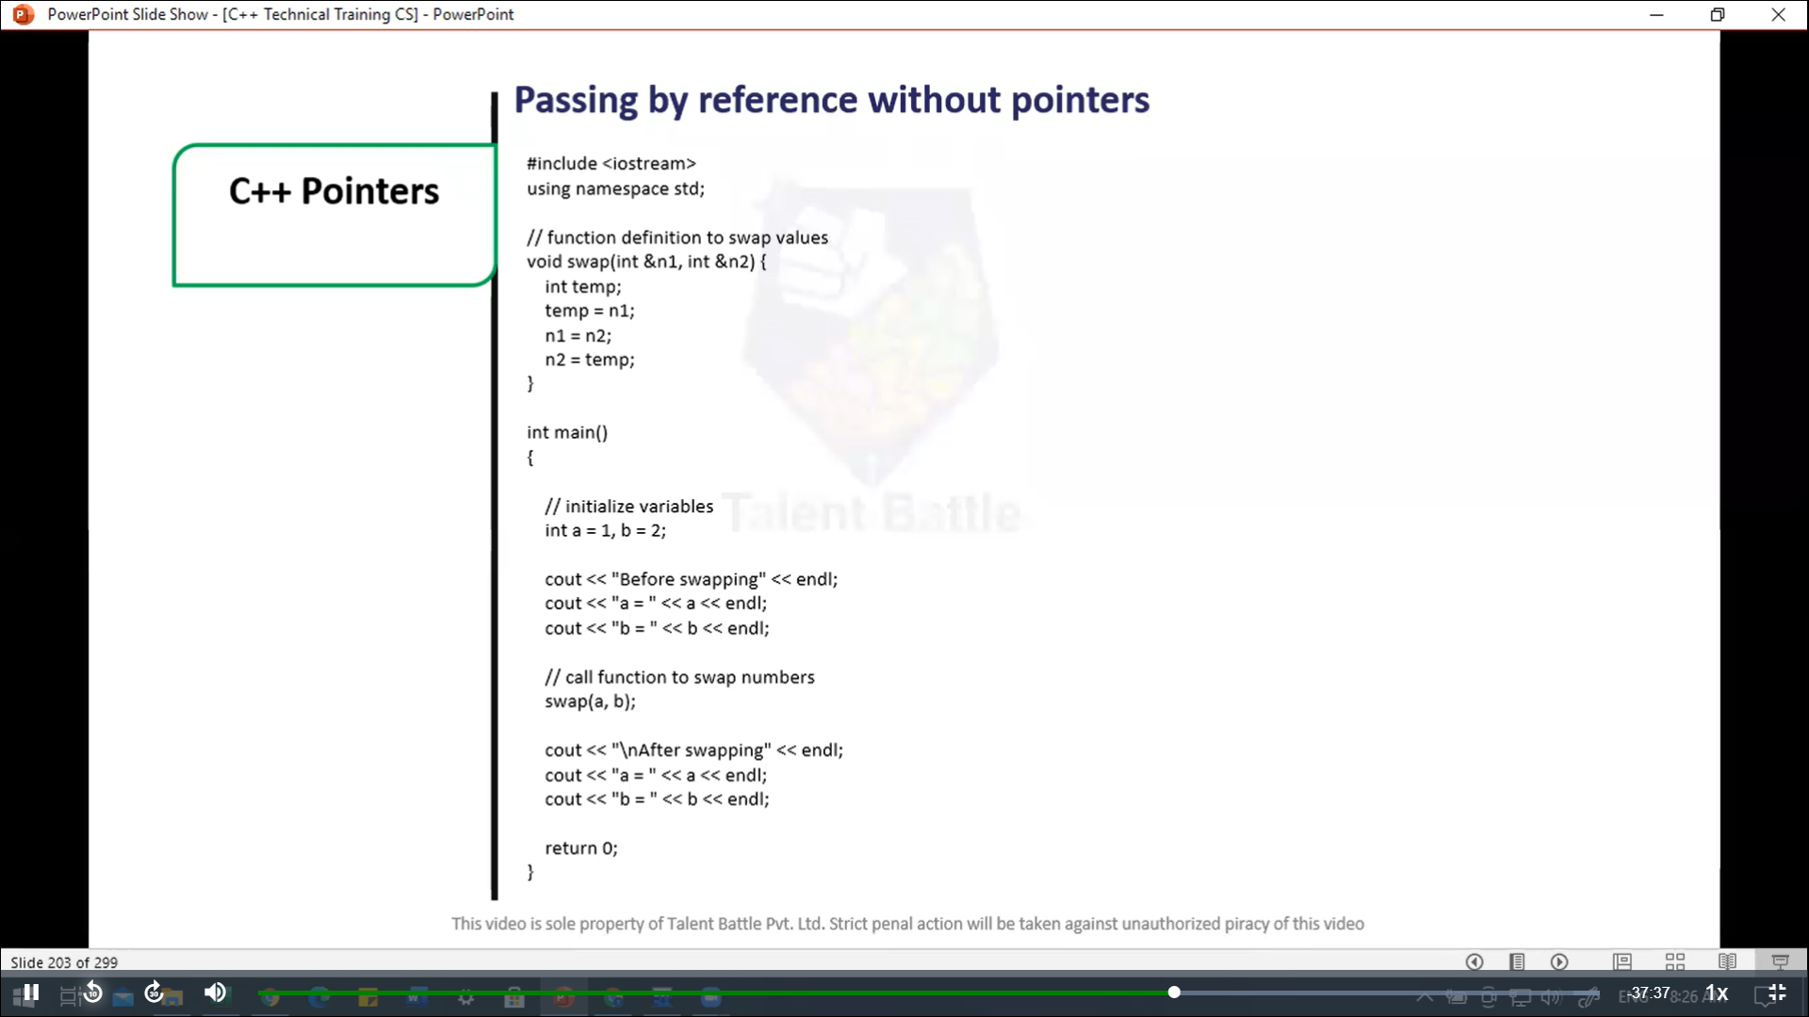

//=================================================

// Passing by reference without pointers

#include<iostream>

using  namespace ***std***;

// function definition to swap values

void *swap*(int &***n1,*** int &***n2***){

  int temp;

  temp = ***n1***;

***n1*** = ***n2***;

***n2*** = temp;

}

int *main*(){

  // initialize variables

  int a = 1***,*** b = 2;

  cout *<<* "Before swapping" *<<* *endl*;

  cout *<<* "a = " *<<* a *<<* *endl*;

  cout *<<* "b = " *<<* b *<<* *endl*;

  // call function to swap numbers

*swap*(a***,*** b);

  cout *<<* "**\n**After swapping" *<<* *endl*;

  cout *<<* "a = " *<<* a *<<* *endl*;

  cout *<<* "b = " *<<* b *<<* *endl*;

  return 0;

}

/*

Before swapping

a = 1

b = 2

After swapping

a = 2

b = 1

--------------------------------

Process exited after 0.117 seconds with return value 0

*/

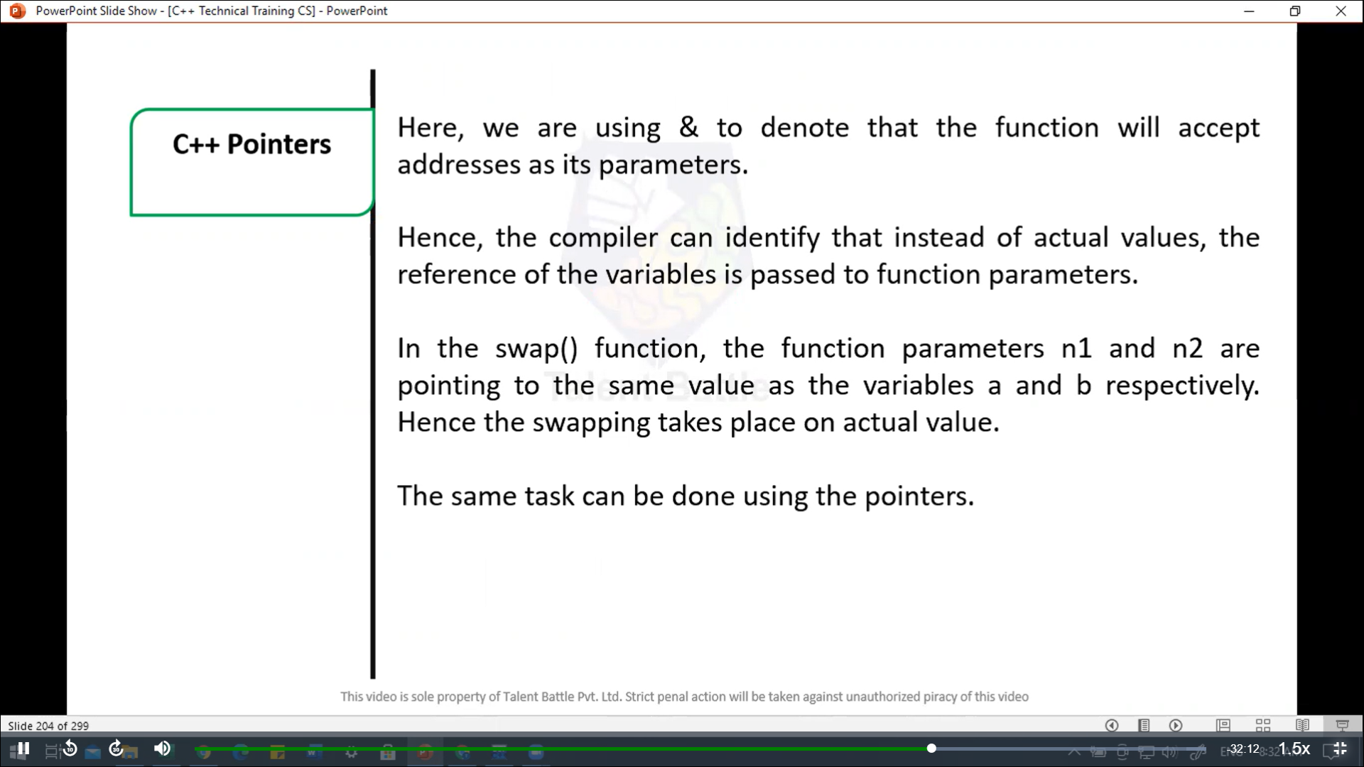

//==================================================

// Passing by reference using pointers

#include <iostream>

using namespace ***std***;

// function prototype with pointer as parameters

void *swap*(int\****,*** int*);

int *main*(){

  // initialize variables

  int a = 1***,*** b = 2;

  cout *<<* "Befor swapping" *<<* *endl*;

  cout *<<* "a = " *<<* a *<<* *endl*;

  cout *<<* "b = " *<<* b *<<* *endl*;

  // call function by passing variable addresses

*swap*(***&***a***,*** ***&***b);

  cout *<<* "**\n**After swapping" *<<* *endl*;

  cout *<<* "a = " *<<* a *<<* *endl*;

  cout *<<* "b = " *<<* b *<<* *endl*;

  return 0;

}

// function definition to swap numbers

void *swap*(int* ***n1,*** int* ***n2***){

  int temp;

  temp = \****n1***;

  \****n1*** = \****n2***;

  \****n2*** = temp;

}

/*

Befor swapping

a = 1

b = 2

After swapping

a = 2

b = 1

--------------------------------

Process exited after 0.1636 seconds with return value 0

*/

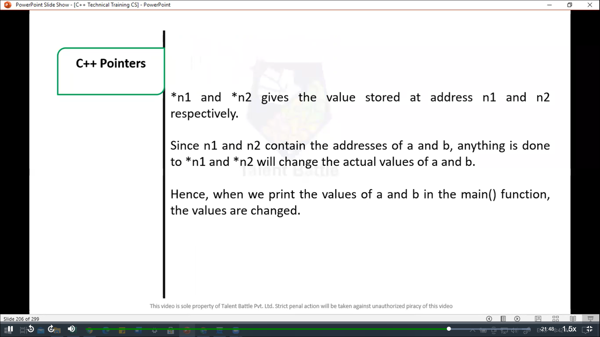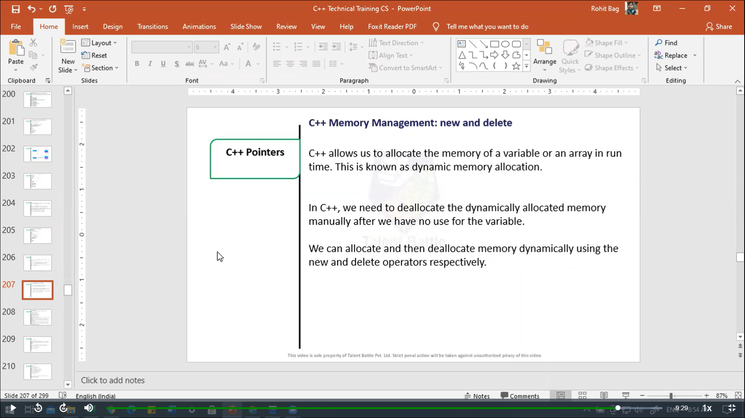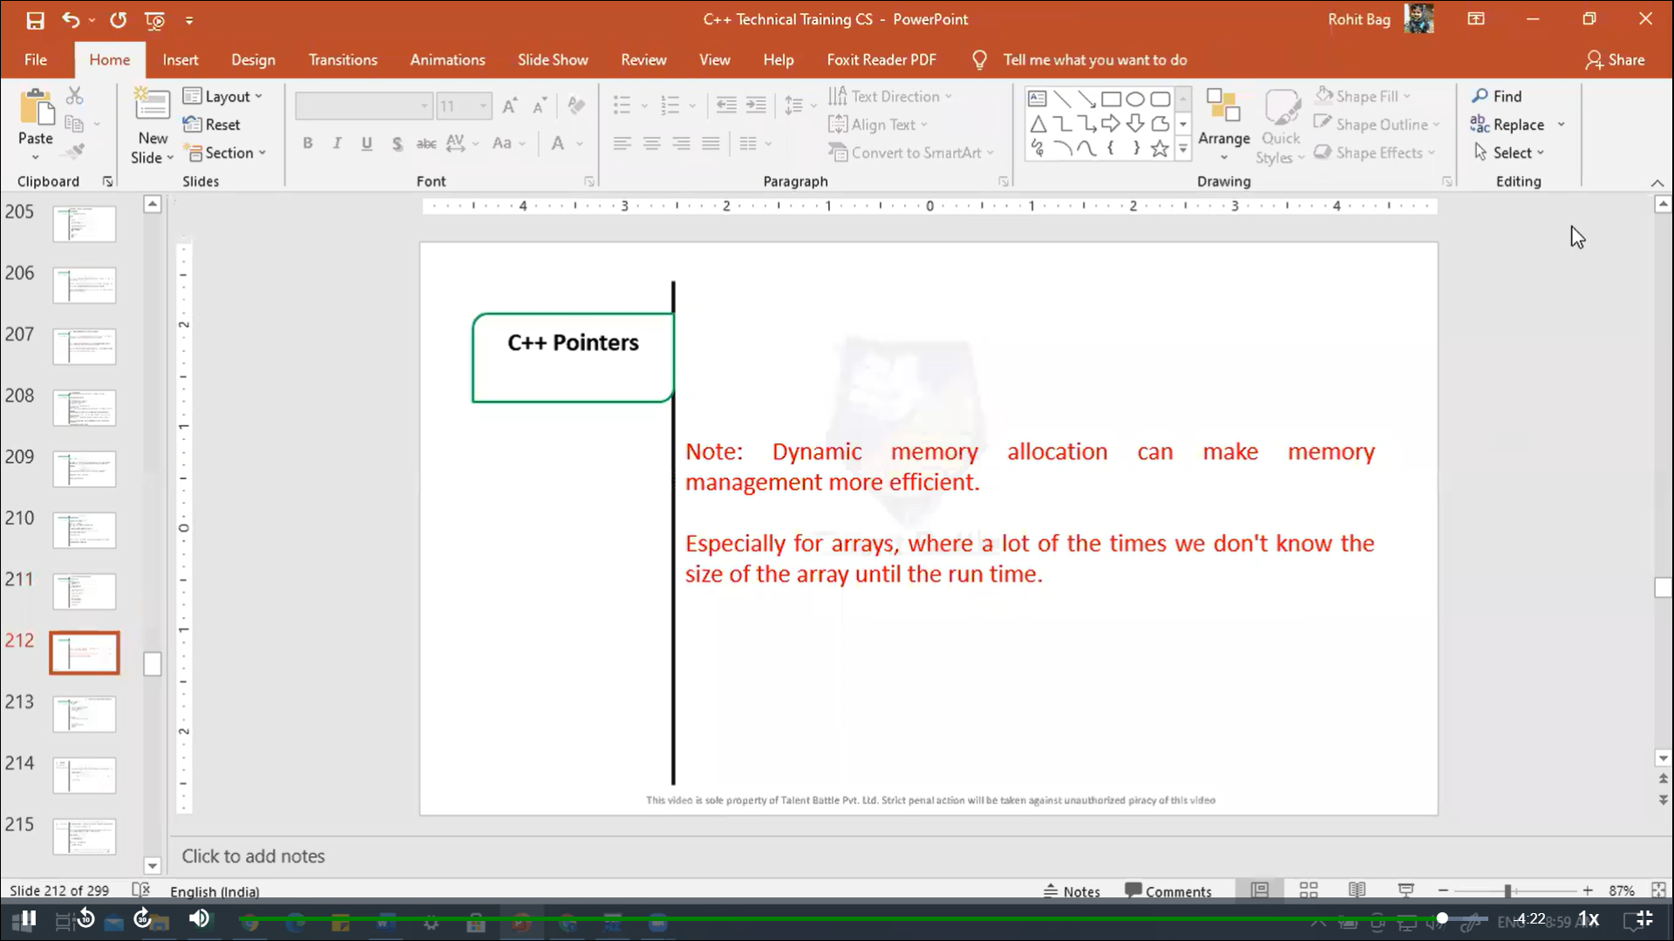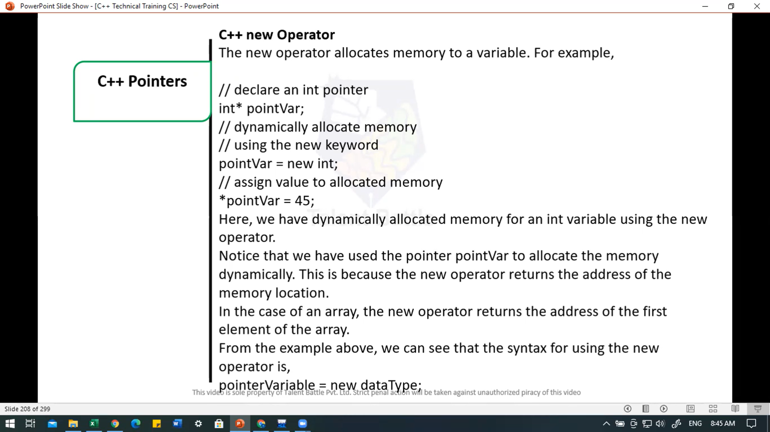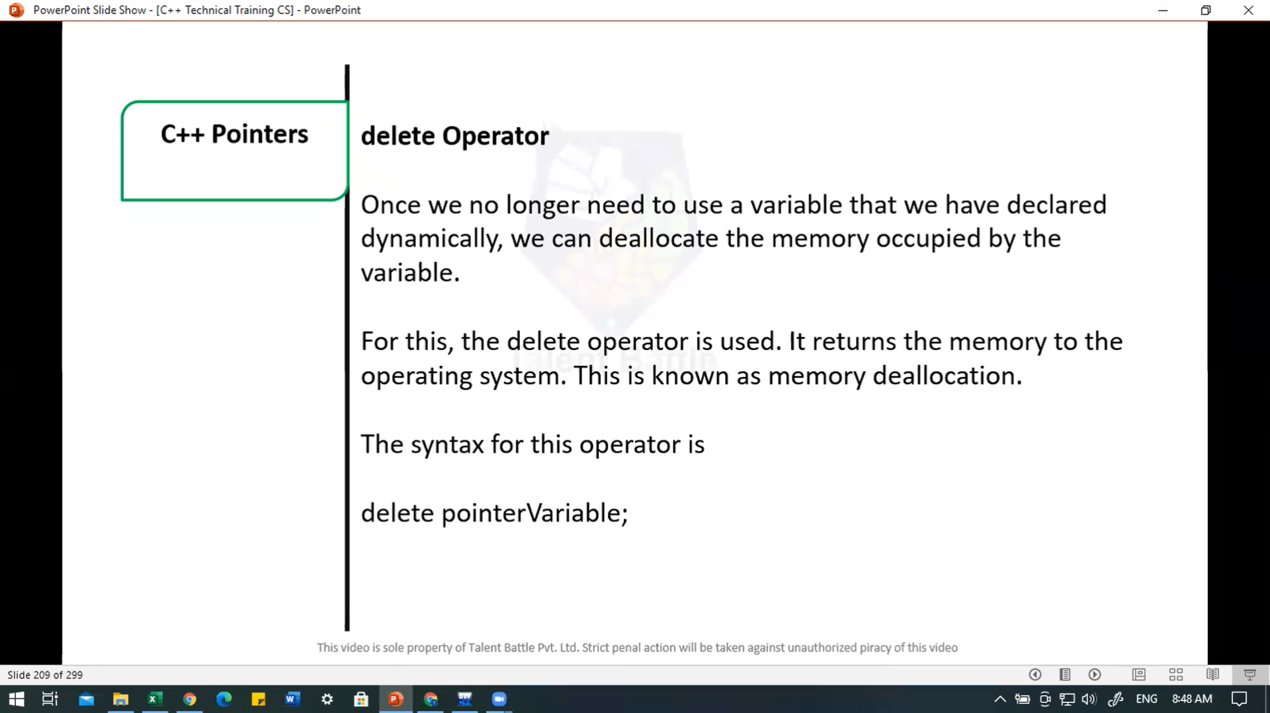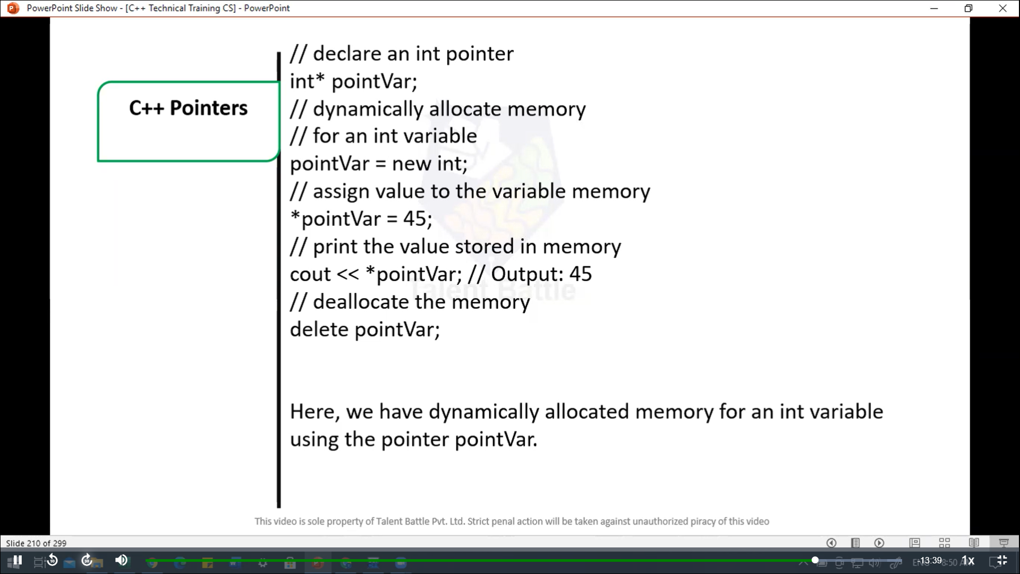

//====================================================

// C++ Dynamic memory allocation

#include<iostream>

using namespace ***std***;

int *main*(){

  // declare an int pointer

  int* pointInt;

  // declare a float pointer

  float* pointFloat;

  // dynamically allocate memory

  pointInt = new int;

  pointFloat = new float;

  // assigning value to the  memory

  *pointInt = 45;

  *pointFloat = 45.45f;

  cout *<<* *pointInt *<<* *endl*;

  cout *<<* *pointFloat *<<* *endl*;

  // deallocate the memory

  delete pointInt;

  delete pointFloat;

  return 0;

}

/*

45

45.45

--------------------------------

Process exited after 0.1411 seconds with return value 0

*/